# Analysis of global temperature change based on R and tableau

Yiwen Liu1,2

1 Department of Ocean Sciences and Engineering, Southern University of Science and Technology, Shenzhen, China

2 Center for Oceanic and Atmospheric Science at SUSTech (COAST), Southern University of Science and Technology, Shenzhen, China

# Background

The global average temperature has risen at the fastest rate in recorded history over the past 50 years. And experts see the pattern accelerating: all but the 16 hottest years have occurred since 2000 on NASA's 134 year record. On the other hand, climate change deniers claim that in global temperature increases there is a "pause" or "slowdown" which has been debunked by several recent reports, including the research paper published in 2015. Glaciers melt, sea levels rise, clouds and trees vanish, and wildlife is racing to catch up. Clearly, much of the warming of the past century has been caused by humans. Release heat for modern life while supplying power.The major driving forces of climate change in the industrial age are greenhouse gas emissions from human activity, in particular fossil fuel burning, deforestation and land use change. The air, water and land of the earth are linked by gas exchange with the atmosphere. The interaction of gases between the earth and its atmosphere encourages natural and human activities (including clouds)

Several other aspects of the global environment are also shifting, including not only average temperature rises, but also extreme weather events, changes in populations and ecosystems of animals, increasing sea levels, and a host of other impacts. As humans continue to inject and capture greenhouse gases into the environment, all these changes are occurring, shifting the climate rhythm that all living things depend on.

What are we going to do? What will we do to cope with this man-made global warming and slow it down? How are we going to respond to the changes enacted? This research will explain global warming to you by reviewing scientific evidence.

# Project introduction

In this project, I focused on the causes of the temperature rise. Therefore, I used RStudio to carry out exploratory data analysis on climate change data, visualize the temperature change, explore the relationship between CO2 and other greenhouse gases and temperature change, and visualize the changes of ice sheet and sea level, and show the impact of global warming on some natural environment through images. The dataset from the World Bank and the file climate_change.csv contains climate data from May 1983 to December 2008. The available variables include: Year、Month、MEI、CO2、CH4、N2O、CFC-11、CFC-12、TSI 、Aerosols ,Temp.

Here CO2, N2O and CH4 are expressed in ppmv (parts per million by volume.CFC.11 and CFC.12 are expressed in ppbv (parts per billion by volume). Before cleaning and analyzing the dataset we will include some libraries that needed in RStudio.



# Handling Missing Data

It might happen that your dataset is not complete, and when information is not available we call it missing values. In R, missing values are represented by the symbol **NA** (not available). Impossible values (e.g., dividing by zero) are represented by the symbol **NaN** (not a number).

Now create a new data set without missing data.



Then, let’s explore something by using the dataset.

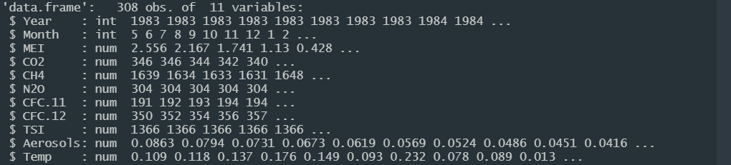

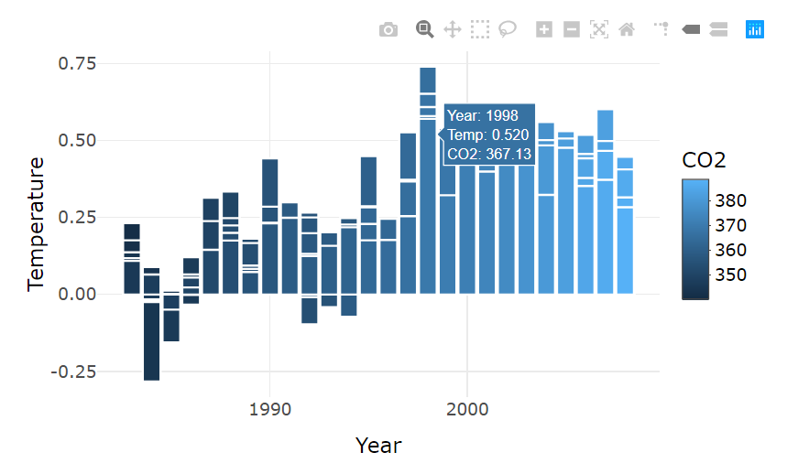

Figure1 Carbon dioxide and temperature distribution

Information on the global annual mean temperature relative to the 1951-1980 mean temperature in the temperature dataset. The map shows the change of global surface temperature from 1983 to 2008 relative to the average temperature from 1951 to 1980.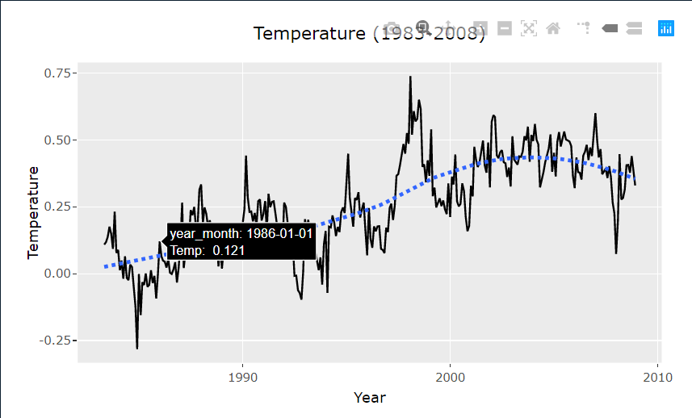

Figure2. Temperature time series distribution

At this point, many people must have doubts in their minds. **Will there always be a rise in temperature trend?**

I have been investigating the IPCC study here. I included a preliminary observation of a "smaller increase trend" found in the global average temperature since 1998 in the 2013 IPCC study than before. This has contributed to numerous media debates about the phenomenon of "pause" or "Hiatus" in the pace of global warming, and many studies have been carried out.

Then, I want to look at the seasonal temperature difference, so I have this monthly distribution of temperature.

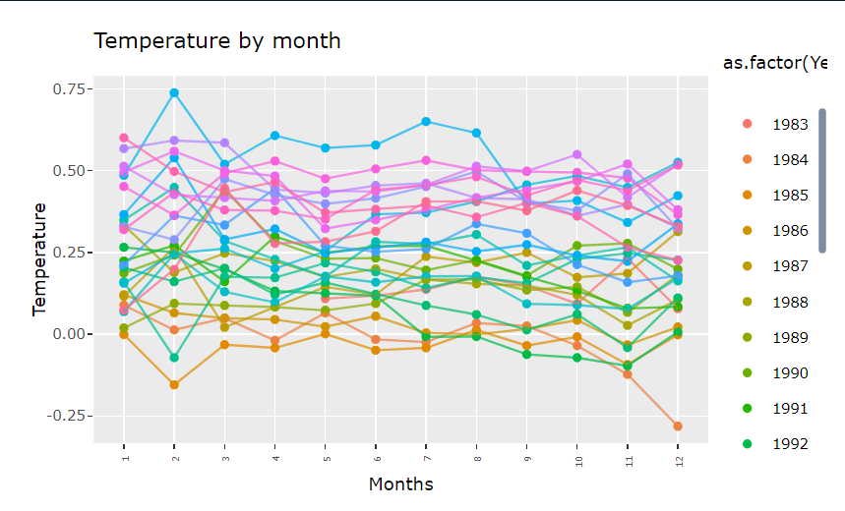

Figure3. Temperature by month

However, it is obvious that such a distribution map is too dense and messy, so I looked up some R packages and used ggridges package to do the following figure.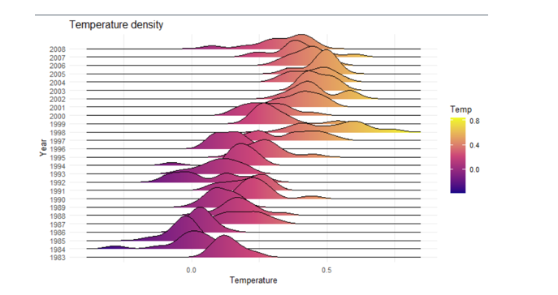

Figure4. Temperature density

It is clear from the picture that our temperature has been rising in the past few decades. Although there was a decline from 2005 to 2008, we noticed that extreme temperature (> 0.5 ° C) occurred in all years since 2000.

Next, I will also visualize the changes of some greenhouse gases.

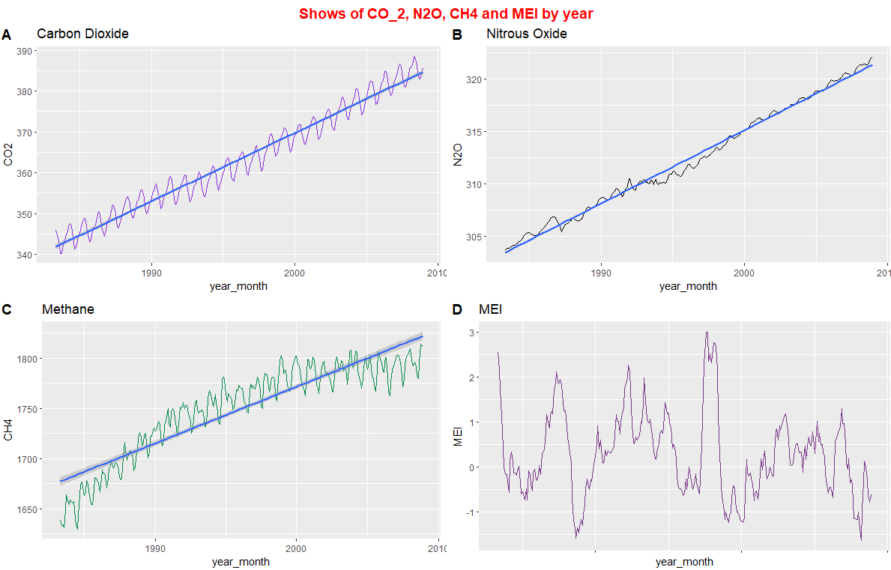

Figure5. Variations of CO2, N2O, CH4 and MEI by year

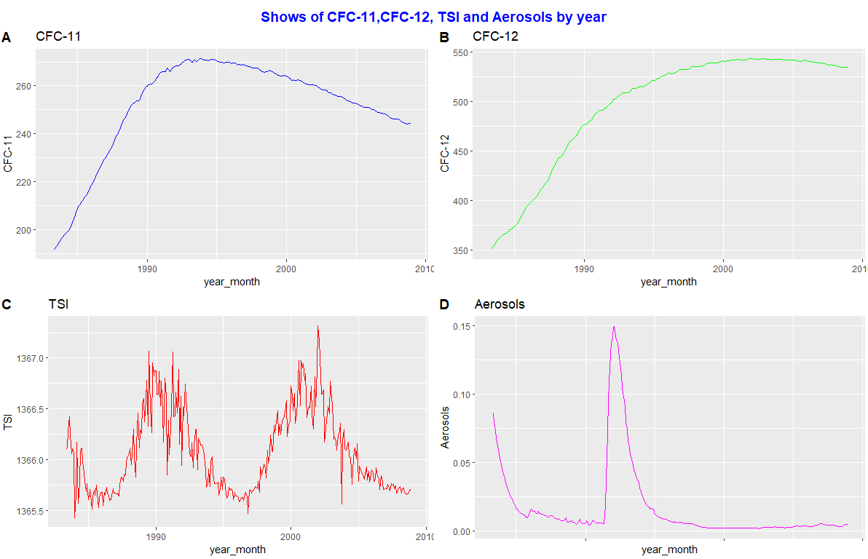

Figure6. Variations of CFC11CFC11, CFC12CFC12, Total Solar Irradiance (TSITSI) and Aerosols by year

CFCs (CFC-11 and CFC-12): we can see that after a steady increase, the content of CFC-11 and CFC-12 decreased after 2000.CFC-11 and CFC-12 emitted the most to troposphere. These CFCs are insoluble in water, so deposition does not remove them from the air. Aerosols are tiny liquid and solid particles suspended in the atmosphere, which can also lead to climate change. Atmospheric aerosols directly affect the climate by scattering and absorbing the incident solar radiation, and indirectly affect the climate by acting as cloud condensation nodules and / or ice nuclei

# Linear regression and multiple regression

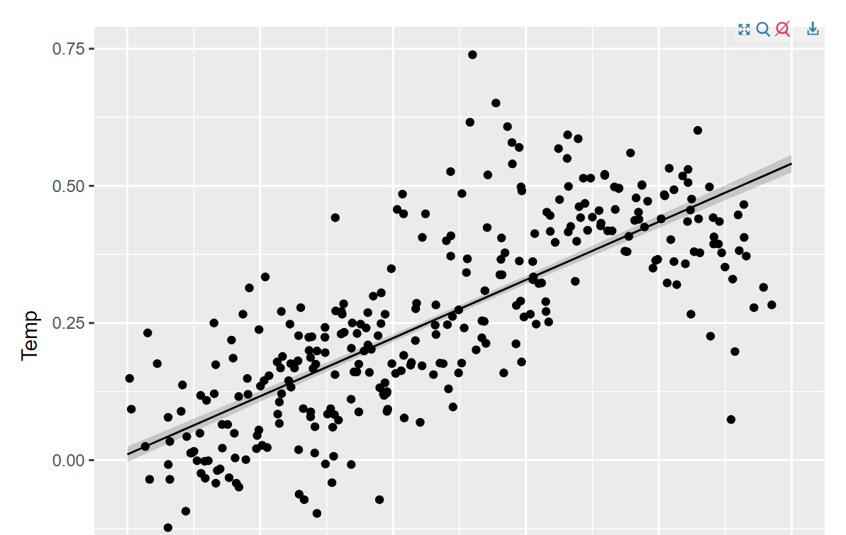

Figure7. Linear Regression Model

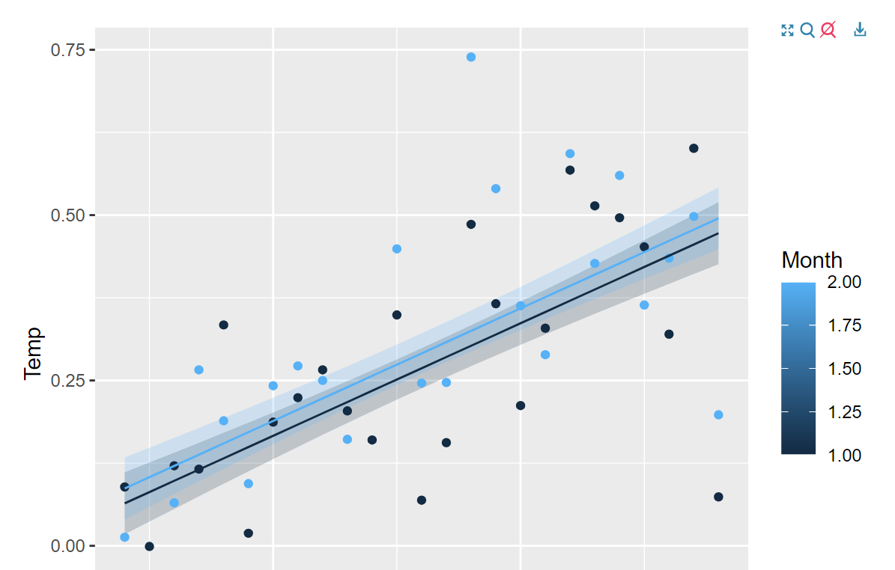

Figure8. Multiple Regression Model

# Animation

I have tried to imagine changes in temperature using the gganimate library animation.



Later, based on tableau, a data visualization tool, I analyzed the distribution of temperature changes in China, as shown in the figure below. Over the years, the temperature changes were obvious and the seasonal differences were significant.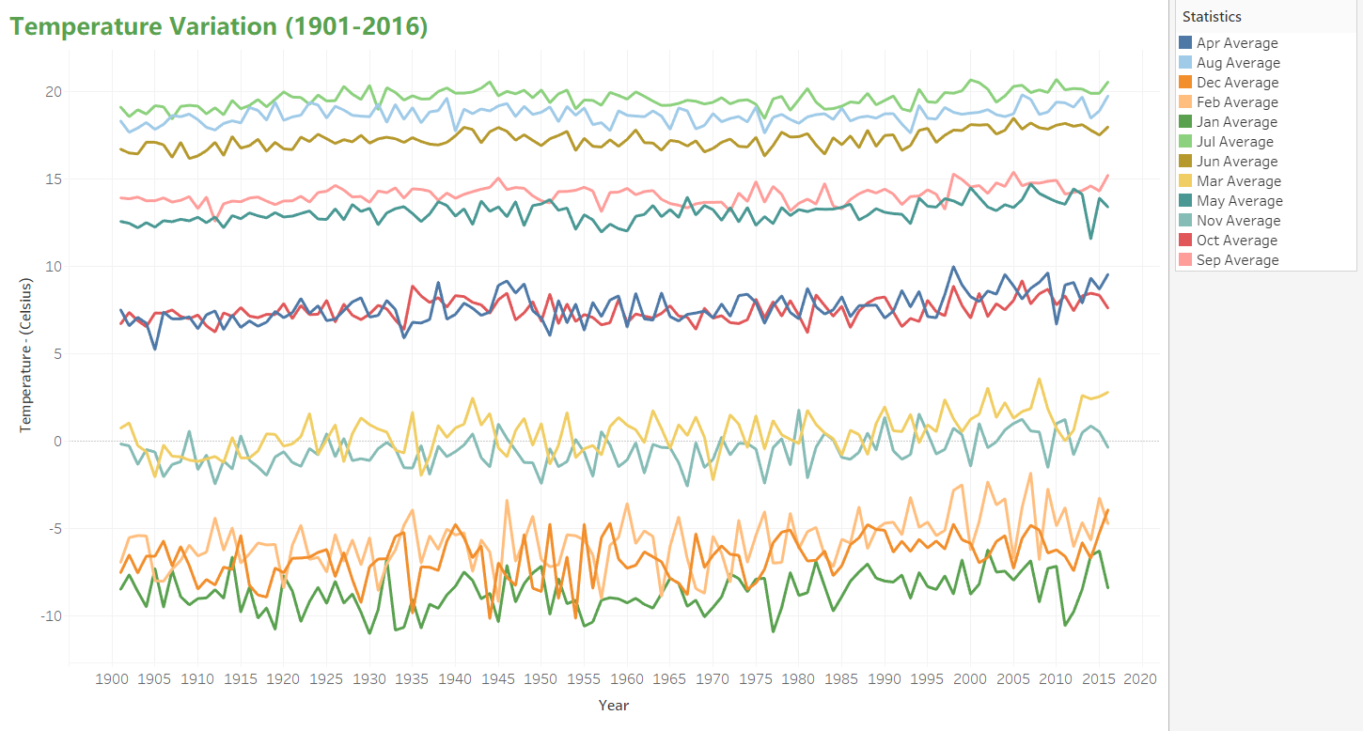

Based on the above, I supplemented and improved the project after the report on December 31. I want to see the real impact of temperature rise on the natural environment, mainly analyzing the changes of ice sheet and sea level. The data set is from NASA's climate change division, and the original data is from the National Oceanic and Atmospheric Administration, specifically the earth system research laboratory

Let's review the trend of carbon dioxide. Carbon dioxide is a greenhouse gas: a gas that absorbs and radiates heat. In the sunlight, the earth's land and sea surface constantly emit thermal infrared energy (heat). The rise of carbon dioxide concentration is mainly because people burn fossil fuels for energy!

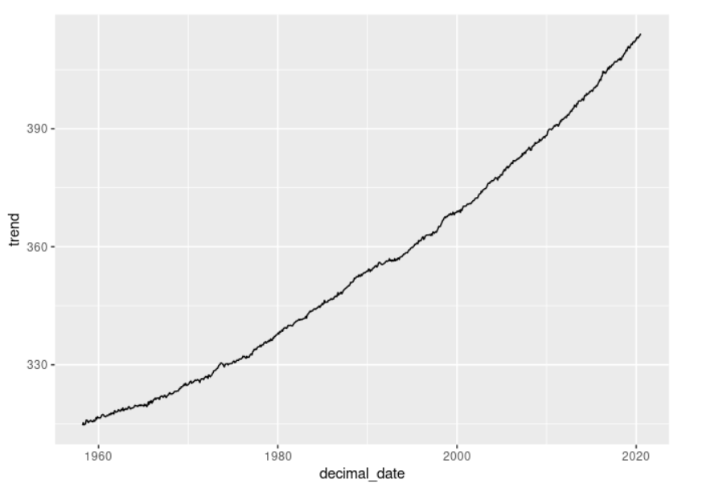

Figure19. Carbon dioxide trends

As mentioned earlier, the temperature data set contains information about the global annual mean temperature from 1880 to 2019 relative to the 1951-1980 mean temperature. The figure below shows the change of global surface temperature relative to the average temperature in 1951-1980.

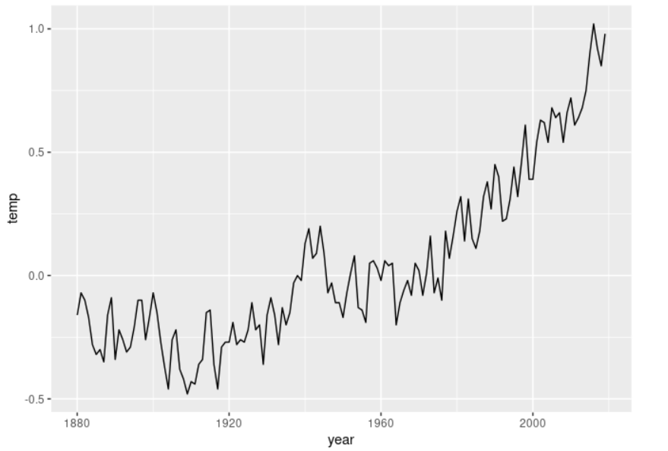

Figure10. Temperature change trend

The overall global temperature trend is rising, according to the map. The global temperature has been growing faster and faster since 2012.

Given the trend shown in the above figure, let's answer the previous question: will the rising temperature trend still rise? In the warming trend, there is no proof of a break. We can clearly see from the figure that, since the early 1960s, the temperature has been increasing at a faster rate. It took about 40 years to rise from below 0 °C to 0.5 °C from 1960 to 2000, but it took less than 20 years to rise from 0.5 °C to 1 °C.

# Melting Ice

In the ocean, sea ice forms and melts. A mass of glacial ice that breaks up and falls into the ocean is an iceberg. The depletion of icebergs has been very severe in the past couple of years. We studied the mass data from the Antarctic (red line) and Greenland (blue line) of NASA's global climate change portion, the ice sheet, in 2002 to investigate this issue.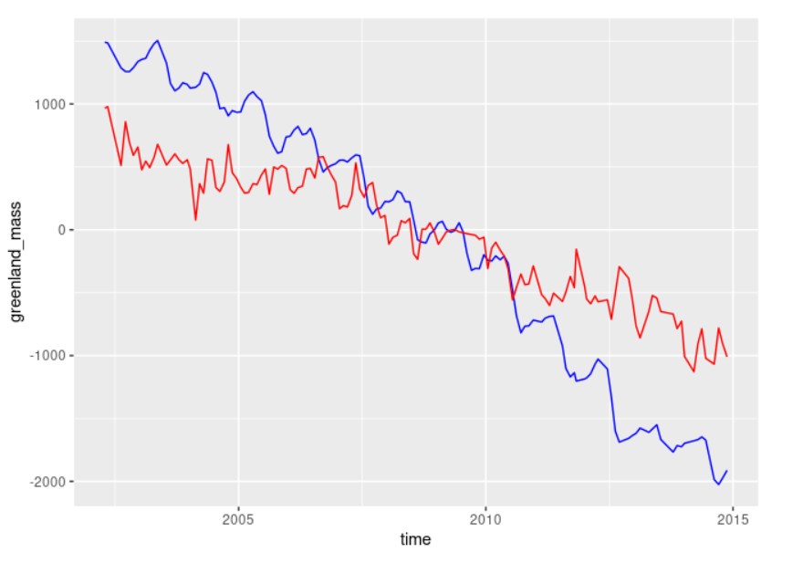

Figure11. Sea ice change trend

The trend is that both ice types are diminishing. There is a wavy pattern every year, which suggests a reduction in summer and a rise in winter. This is because of the normal shift of temperature for numerous reasons. Greenland, however, falls faster than Antarctica. Initially, while Greenland was heavier than Antarctica, now Greenland is less huge than Antarctica.

As rising air and ocean temperatures cause more regular and stronger coastal storms, such as hurricanes and typhoons, melting glaciers exacerbate sea-level rises, which in turn exacerbates coastal erosion and exacerbates storm surges.

# Rising Sea Level

Sea level rise is another important indicator of climate change. According to NASA, sea-level rise is mainly caused by two factors: melting ice sheets and increased water from glaciers, and the expansion of sea water as the sea warms. We analyzed sea level rise - sea level change based on information provided by NASA's global climate change department.

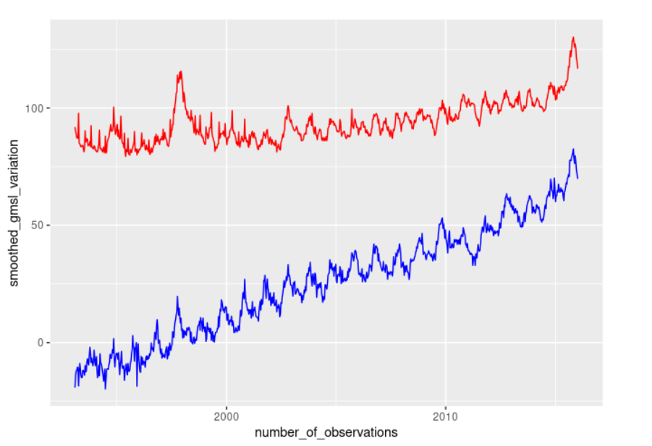

Figure12. Sea Level change trend

# Conclusion

1. From a variety of important indicators, the trend of climate change is very obvious! We can see the increase of CO2, the increase of temperature, the decrease of ice sheet weight, the increase of sea level and the decrease of Arctic sea ice size.

2. All kinds of greenhouse gases affect the climate warming

3. In the past decades, our temperature has been rising. Although there was a decline from 2005 to 2008, we noticed that extreme temperature (> 0.5 ° C) occurred in all years since 2000.

4. The answer to the question of whether the rising trend of temperature will continue to increase is that there is no evidence of a pause in the warming trend.

5、 From 1901 to 2016, the temperature change in China is obvious, with obvious seasonal differences.

# Acknowledgment

**——So far, the autumn teaching of my elective course is over**

1. I would like to thank Professor Lei Zhu，School of Environmental Science and Engineering

2. Thanks to the two course assistants’ effort

3. Thanks to my roommate Yuan Li for helping me answer the questions I didn't understand in the past courses